SponsorIN

Brandon Tiong

Emanuel Macias

Ege Keser

Table of Contents

Table of Contents2

1. Project Definition3
2. Project Requirements4

2.1 Functional Requirements4

2.2 Usability Requirements5

2.3 System Requirements6

3. Project Specification7

4. System – Design Perspective8

4.1 Subsystem Functional - Architectural Design8

a. User Management Subsystem8

b. Communication Subsystem11

c. Admin Control Subsystem14

d. Company Subsystem16

e. Athlete Subsystem18

f. Search & Discovery Subsystem19

g. UI/UX Subsystem21

h. Backend Processing Subsystem21

i. Data Management Subsystem22

j. Security & Compliance Subsystem22

4.2 Database Design - Entity Relationship Model and Data Dictionary23

4.2.1 Entity Relationship Model23

4.2.2 Database Design24

4.2.2 Data Dictionary25

5. Type chapter level (level 1)18

Type chapter level (level 2)5

Type chapter title (level 3)6

**1. Project Definition**

**Background**

Before 2021, the college athletes around the United States were not able to receive any financial support from their supporters or find a sponsorship because of the NIL (Name, Image and Likeness) restrictions of NCAA (National Collegiate Athletic Association). Due to the recent laws passed in many states, college athletes had the chance to get paid by their supporters as well as started to find sponsorships to build their brands using their own name. However, according to our research, there is no platform that would help college athletes to promote themselves and find a possible sponsorship connection. It’s easier for companies to find talented athletes and sponsor them due to their giant budgets. Unfortunately, that is not the case for athletes.

**What is SponsorIN and how will it help?**

SponsorIN will come into play when college athletes want to promote themselves and find sponsorships easily. SponsorIN is a web application to help college athletes and companies to find each other. SponsorIN will provide college athletes and companies an environment to build network, stay connected, and possibly, build a business relationship. College athletes will be able to promote themselves and look out for sponsorship, while companies are looking for athletes with great potential and help them grow their own brand under their sponsorship.

**How will it be developed?**

We will start developing SponsorIN by developing basic functions that most of the web applications would normally have. These functions include user registration, sign in – sign out and basic search. Then, our team will focus on developing the user specific functions such as sending-accepting-negotiating offers, athlete pool viewing-filtering-sorting, user verification and user editing-deletion. Once we have all the functions up and running, we will connect those functions with associated front-end and database sections so that we will have a complete web application that aims to accomplish our goals.

**2. Project Requirements**

#### **2.1 Functional Requirements**

* **User Types**: Three different types of users—Admin, Company, and Athlete—with distinct permissions and functionalities.

**Common Features for All Users**

* **Login & Authentication**: Secure login process for Admins, Companies, and Athletes.
* **Profile Creation & Editing**: Customizable profiles to add and edit pertinent details.
* **Messaging System**: In-app secure messaging for communication between all user types.
* **User Search**: Ability to search for other users based on relevant criteria.

**Admin-Specific Features**

* **Profile Verification**: Exclusive rights to verify the profiles of Companies and Athletes.
* **User Editing & Deletion**: Capability to edit or delete any user profiles.

**Company-Specific Features**

* **Send Offers**: The ability to send sponsorship offers to Athletes.
* **Organized Watchlist**: A feature to save and organize a list of Athletes they are interested in.
* **Filtered Athlete Pool**: Advanced search and filters specific to finding suitable Athletes.

**Athlete-Specific Features**

* **Accept/Decline/Counter Offers**: The ability to interact with offers from Companies by accepting, declining, or sending a counteroffer.

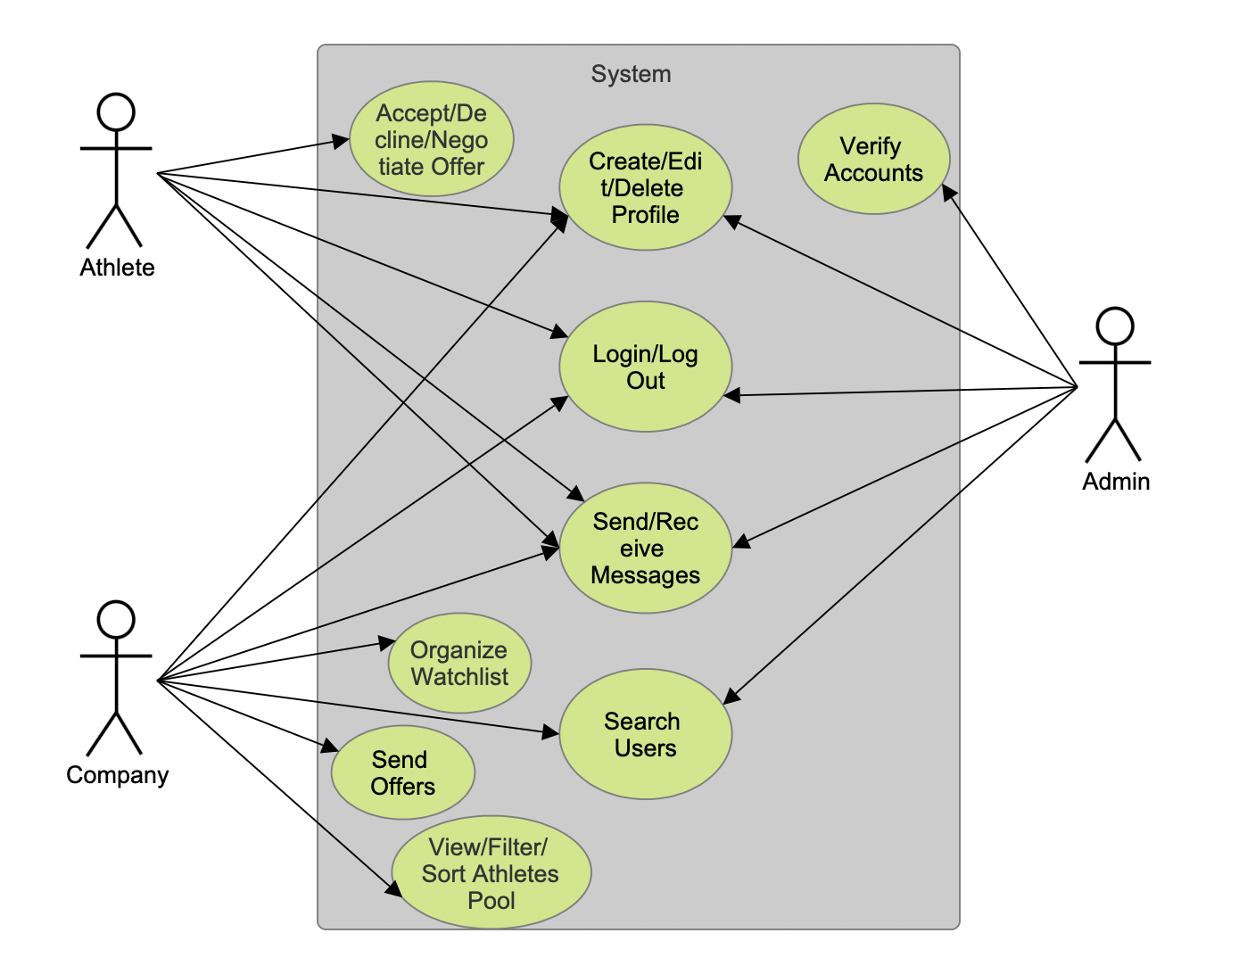

#### **2.2 Usability Requirements**

##### **User Interface**

* **Responsive Design**: The web app should be accessible and usable on various devices including smartphones, tablets, and desktops.
* **Intuitive Navigation**: Menus and sub-menus should be easy to understand and navigate.
* **Information Architecture**: Efficient categorization of information for easy retrieval and action.

##### **Performance**

* **Load Time**: The web application should load within 3 seconds to provide a seamless user experience.
* **Scalability**: The system should be able to handle a growing number of users and data.
* **Error Handling**: Graceful error messages and solutions should be provided for common issues.

#### **2.3 System Requirements**

##### **Hardware**

* Since the application is web-based, the hardware requirements are minimal; users need a device with internet connectivity. On the server side, robust cloud servers may be used for better scalability and performance.

##### **Software**

* **Back-End**: Python Flask for server-side logic.
* **Front-End**: HTML, CSS, JavaScript and Bootstrap for UI/UX.
* **Web Server**: A server capable of running Python, such as Apache or Nginx.

##### **Database**

* **Database Engine**: PostgreSQL
* **Data Backup**: Regular automated backups.
* **Data Integrity**: ACID compliance to ensure data integrity.

#### **Security Requirements**

* **Data Encryption**: Data should be encrypted during transit and at rest.
  + This will be done by HTTPS, and SSL certificate
* **Authorization**: Role-based access control for different types of users.
* **Secure APIs**: All APIs should be secure and only accessible through authorized methods.

By addressing these requirements, the project will provide an efficient and secure experience for both athletes and companies.

**3. Project Specification**

* **Area of Focus**

The primary focus of the application is to create a web application that connects college athletes and sponsoring companies, in compliance with the newly updated NCAA regulations. Our target audience includes college athletes seeking sponsorships and companies interested in sponsoring athletes to promote their products or service.

* **Libraries, Frameworks and Development Environment**

The web application will primarily be developed using Python Flask for the backend, HTML, CSS, and JavaScript for the frontend, and PostgreSQL for the relational database. The framework will include React to enhance the frontend.

* **Platform**

The primary platform will be web-based for desktop browsers.

* **Genre**

The application SponsorIN falls under the Business Networking and Sports Management genre.

* **Source Code**

Source code for the SponsorIN project can be accessed through the link below:

<https://github.com/twosize/SponsorIN>

* **Introduction and Demo Video**

Introduction and demo video can be accessed through the link below:

<https://youtu.be/hkl0gRBrgX0?feature=shared>

* **Team Members**

1. Brandon Tiong: <https://github.com/twosize>
2. Emanuel Macias: <https://github.com/DarkNeo777>
3. Ege Keser: <https://github.com/egekeser>

* **Responsibilities**

1. Brandon Tiong: Full-Stack Developer, mainly backend.
2. Emanuel Macias: Full-Stack Developer, mainly frontend.
3. Ege Keser: Full-Stack Developer, mainly data, documentation and support for backend and frontend.
4. **System – Design Perspective**

### ***4.1 Subsystem Functional - Architectural Design***

#### **a. User Management Subsystem:**

* **Description**: Handles user registration, authentication, profile management, and Users (Admin, Company, Athlete).
* **Components**:
* Registration & Sign In/Out.
* User-Based Access Control.
* Profile Creation & Editing.

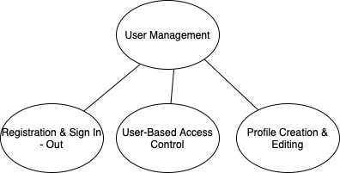

Sign-in:

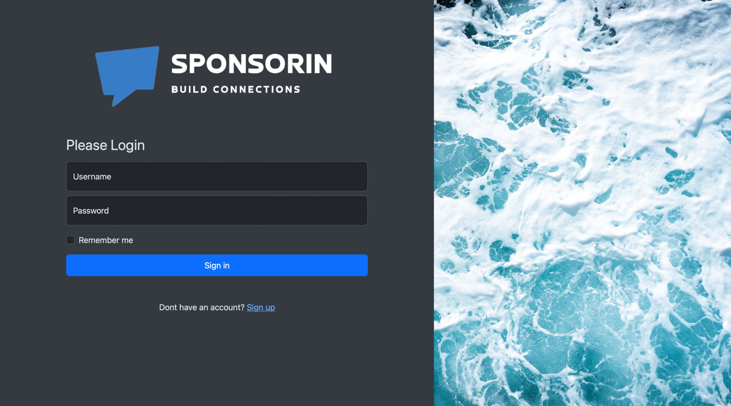

If the users are registered before, they will be able to sign in using their credentials which is the username and the password.

Register:

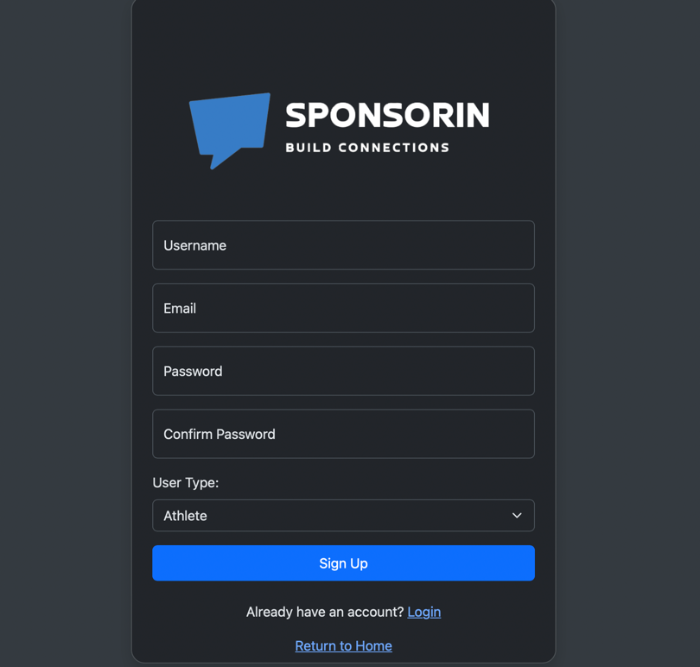

Companies or College Athletes who wants to use SponsorIN are required to register with their information to access the full functionalities of the software. Users will be able to register for SponsorIN by entering a username, email, password, and password once again one more time. At the end, user will be prompted to choose their type. In that case, they can either register as an Athlete or as a Company. No user can register as an admin since admins are the only people who can create other admin users.

Create – Edit Profile:

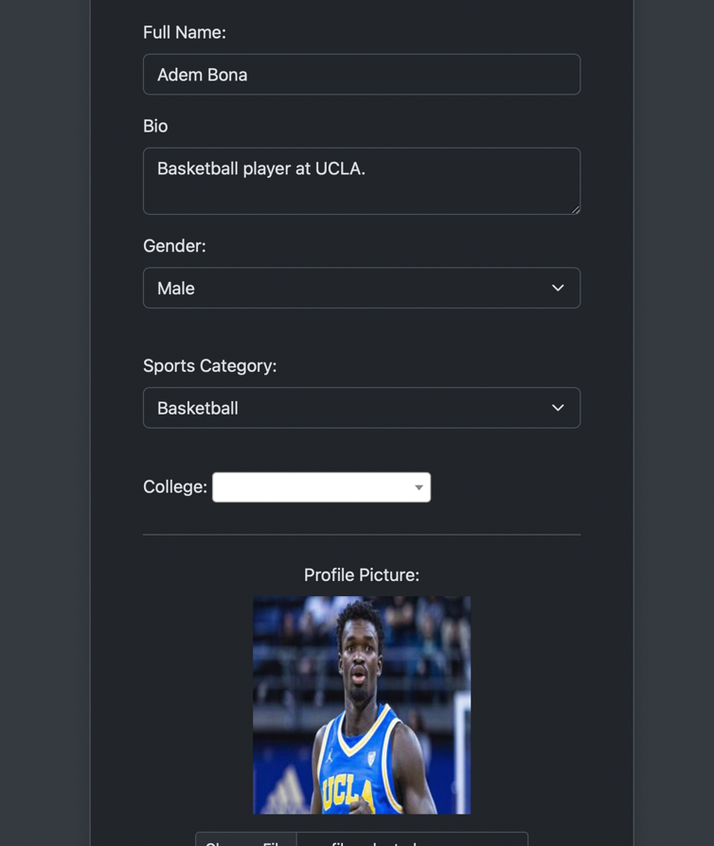

All athletes and companies registered to our system are required to create a profile for themselves. If they register as an athlete, they will need to create a profile that includes their full name, biography, gender, the sports they play, the college they attend and their profile picture. Company will only have biography, company name, full name for company’s representative who uses the account and their logo.

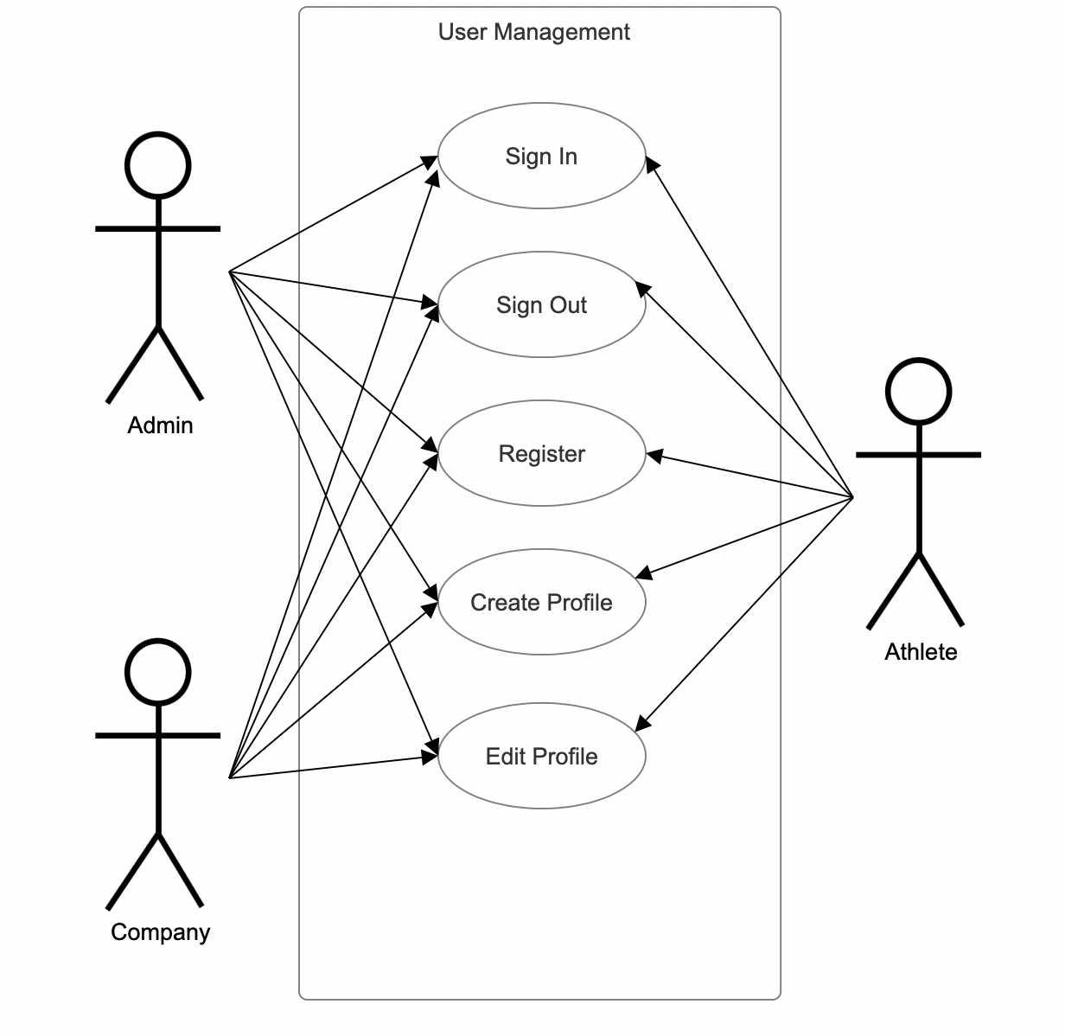

#### **b. Communication Subsystem:**

* **Description**: Allows in-app messaging between companies and athletes, including offer negotiations.
* **Components**:
* Messaging System.
* Offer Management (Create, Accept, Decline, Counter).

Send Message:

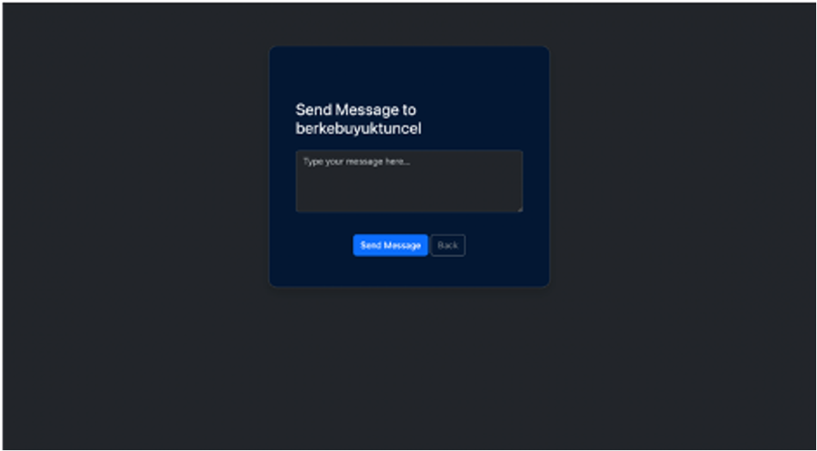

Users will be able to send messages to each other to build connections or if they need any type of communication or technical support from admins. Athletes will be able to send messages to admins and companies, but they will not be able to communicate with each other. Admins are allowed to send messages to both companies and athletes.

Send Offer:

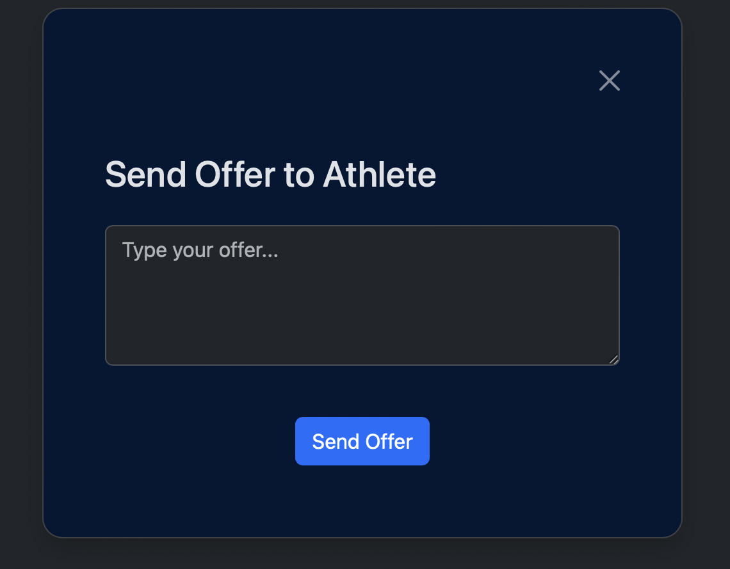

Users are allowed to send sponsorship offers to each other. First offer must be sent by a company to an athlete. Then, athletes will have the option to accept, decline or provide a counteroffer. There is no upper limit for counter limits between athletes and companies. Once an offer is sent by a company, they will have the ability to modify or retract the offer.

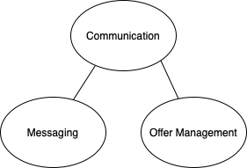

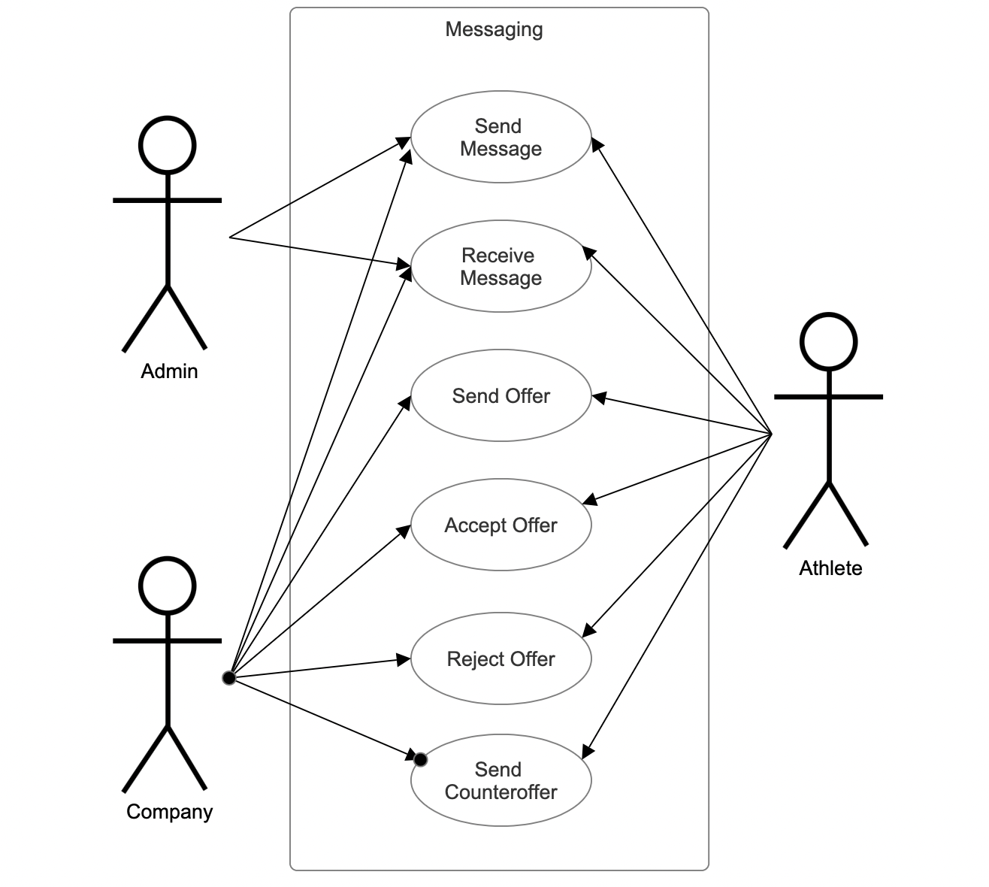

#### **c. Admin Control Subsystem:**

* **Description**: Provides control for administrators to oversee, validate, and intervene when necessary.
* **Components**:
* Profile Verification.
* User Editing & Deletion.

Profile Verification:

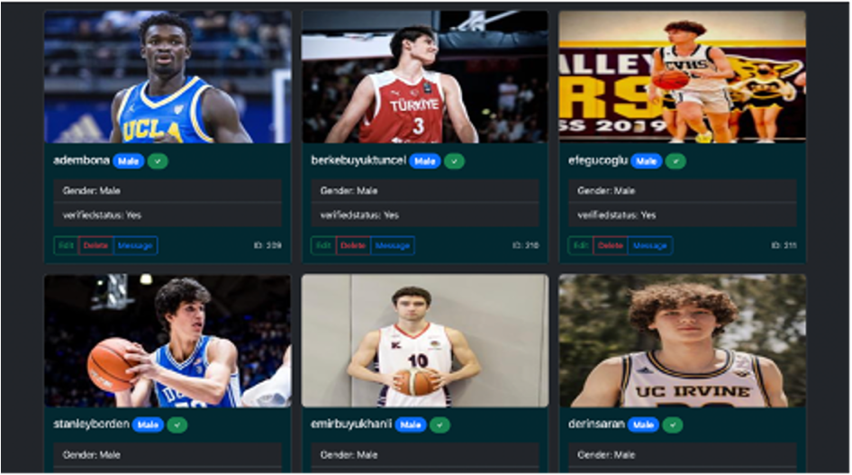

Each user has to have their profile verified and there is only one way of getting the profile verified. Once a user registered for SponsorIN and created their profile, the profile will come up as created but not verified. If a profile is not verified, no one will be able to see their profile except admins. If an athlete created their profile but it is not verified yet, companies will not be able to see this athlete. It’s exactly the same situation for the companies too. Only users who can verify profiles are admins. There is no such a thing called self-verification.

Edit User:

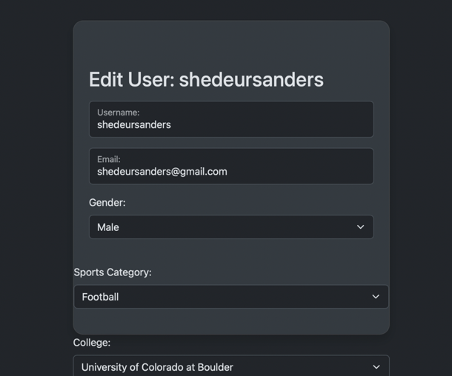

Admins will be able to edit any type of data belongs to the user profile of companies and athletes.

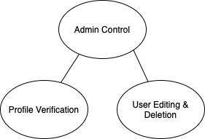

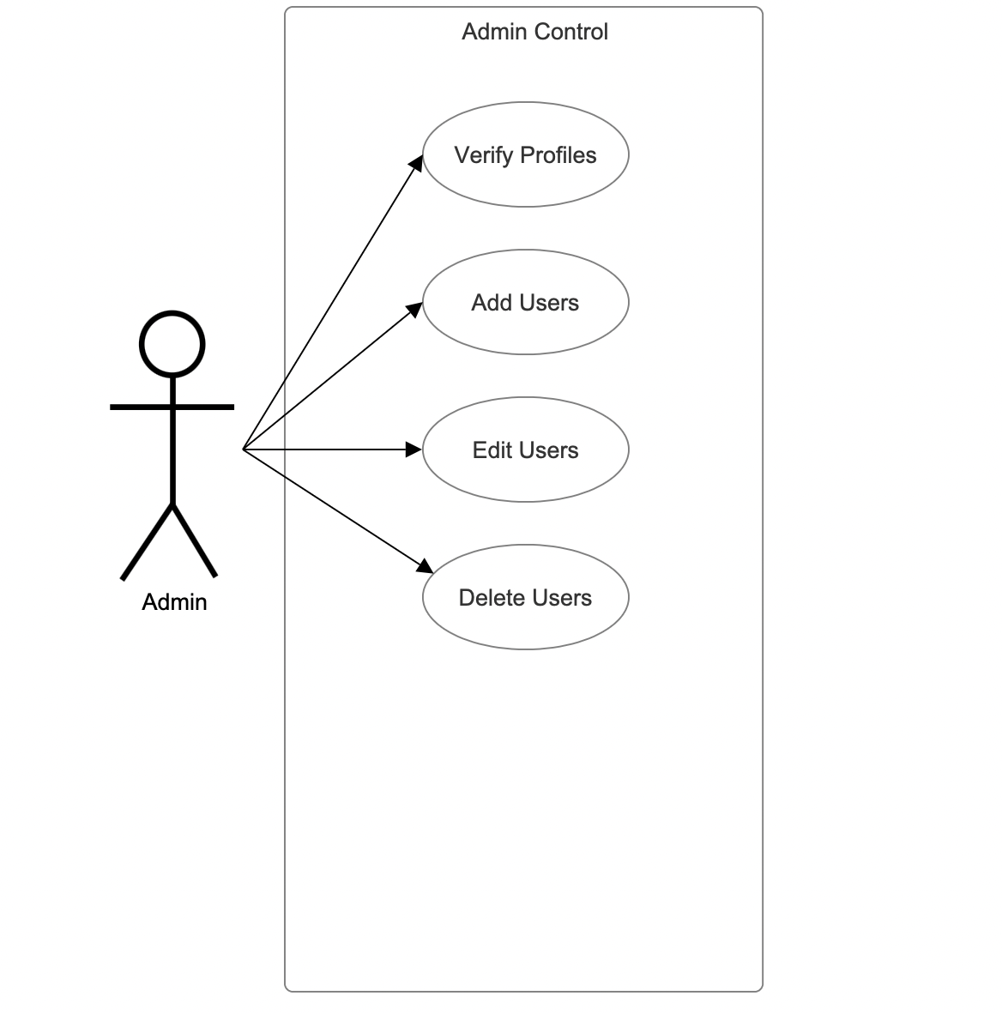

#### **d. Company Subsystem:**

* **Description**: For companies to find, save, and interact with potential athlete profiles.
* **Components**:
* Filtered Athlete Pool.
* Send Offers to Athletes.
* Organized Watchlist.

Organized Watchlist:

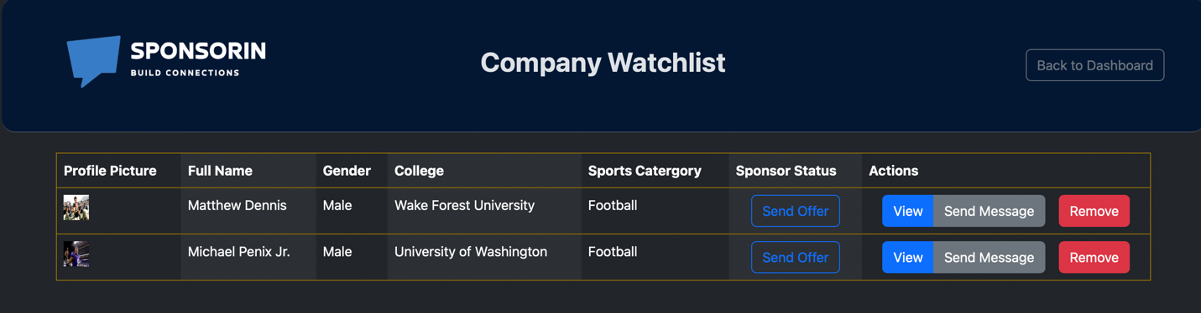

Companies will be able to create a watchlist for themselves to keep only the athletes they are interested in sponsoring. Using the watchlist, companies can send offers and send messages to athletes. They will always have the ability to remove an athlete from the watchlist.

Filtered Athlete Pool:

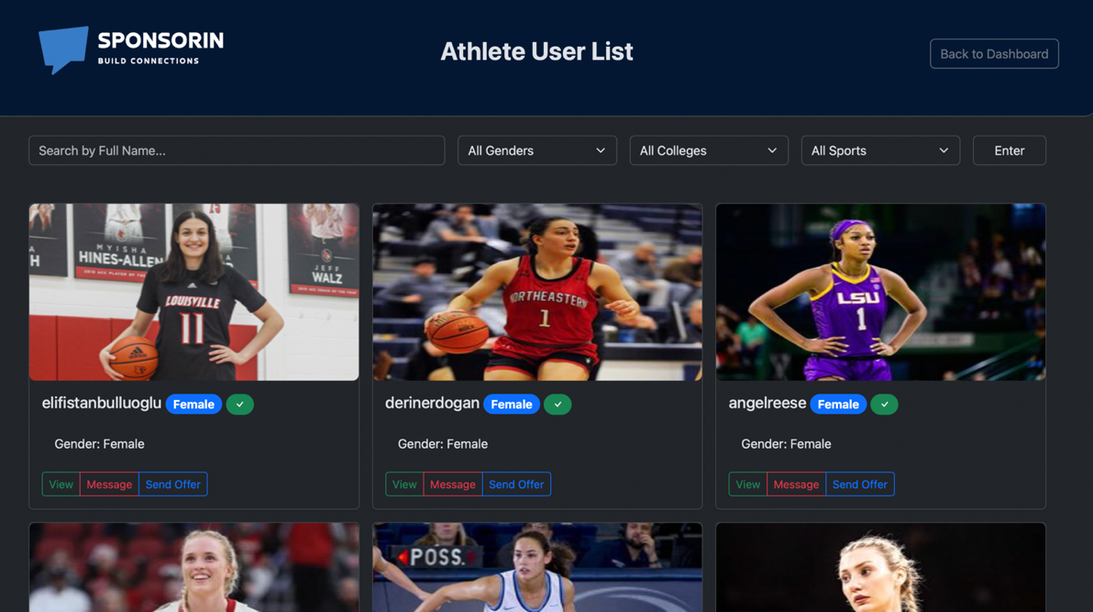

Companies are able to look at the large database of players from different categories. If they are looking for specific categories and choices, they have the option to use filtering and see the athletes related to their filters. Companies can use sports filtering and pick basketball, soccer, and football. They can also filter based on the colleges and gender.

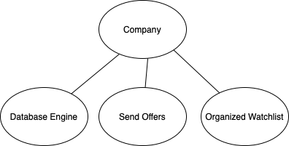

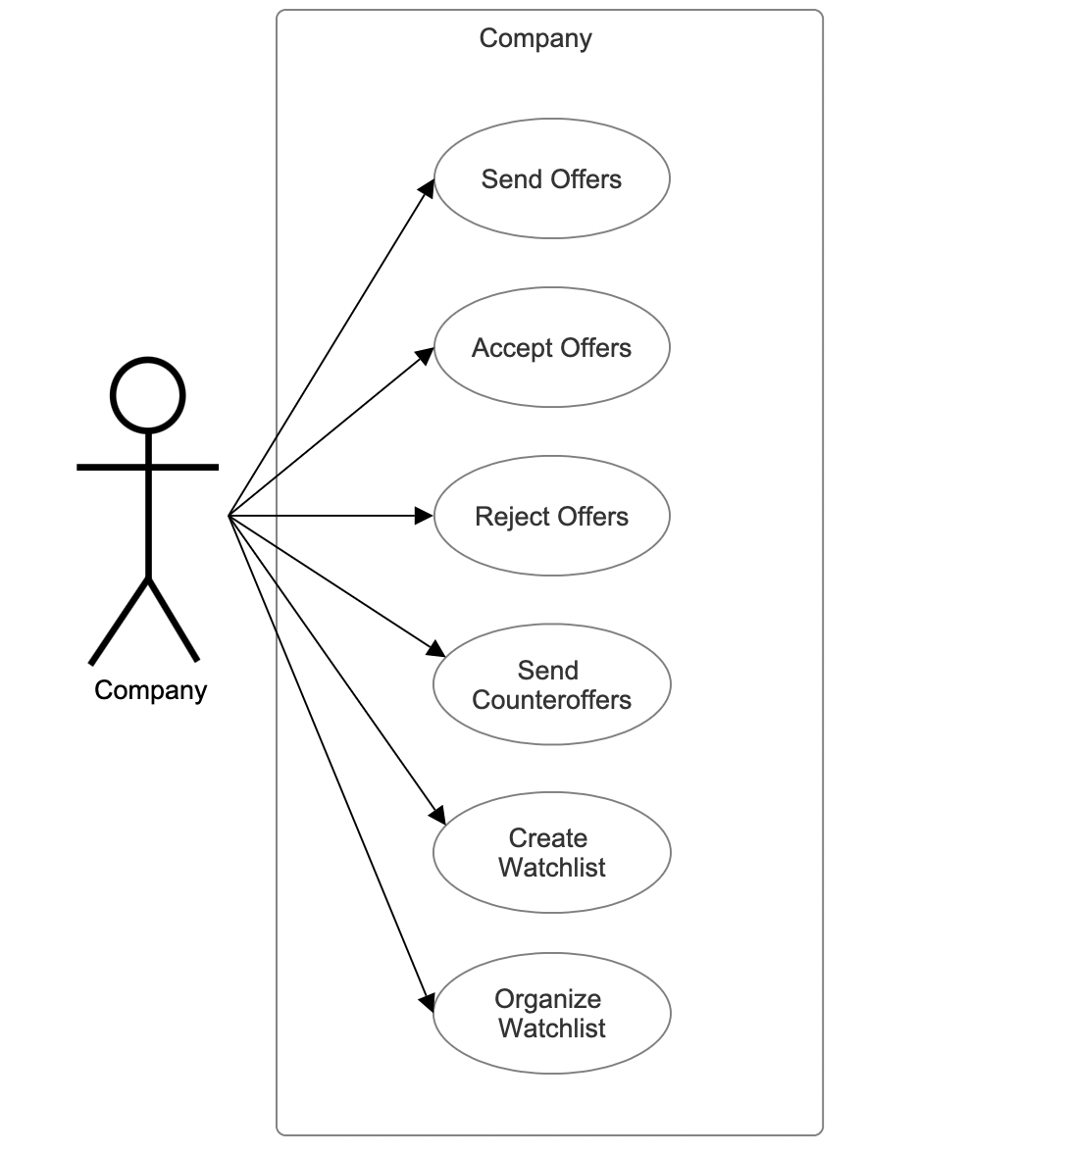

#### **e. Athlete Subsystem:**

* **Description**: Enables athletes to market themselves effectively and interact with companies.
* **Components**:
* Profile Customization & Showcase.
* Accept/Decline/Counter Offers.

Accept / Decline / Counter Offers:

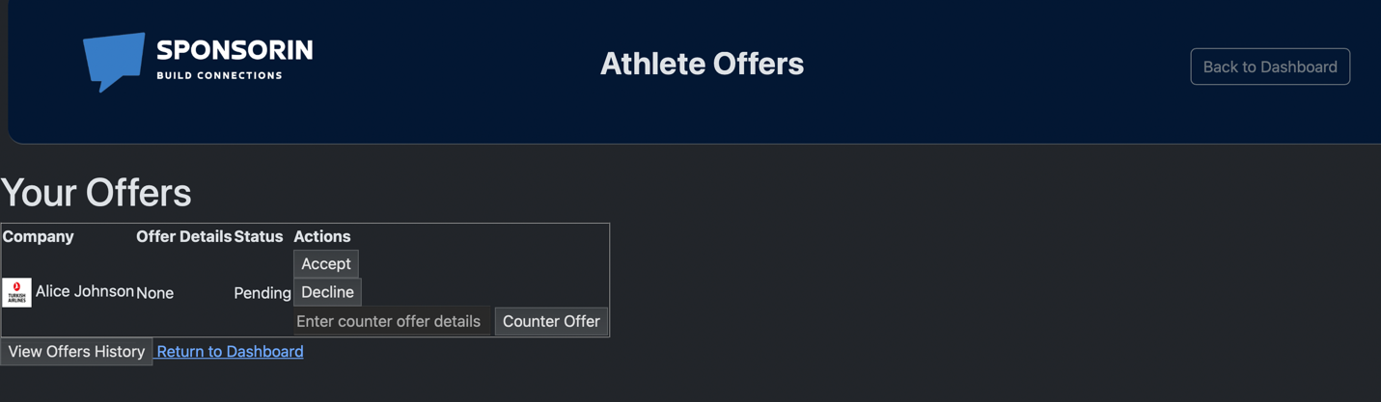

Athletes will be able to accept, decline or give a counteroffer and ask for better conditions. However, they will never be able to be the one who gave the first offer.

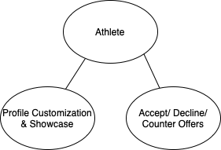

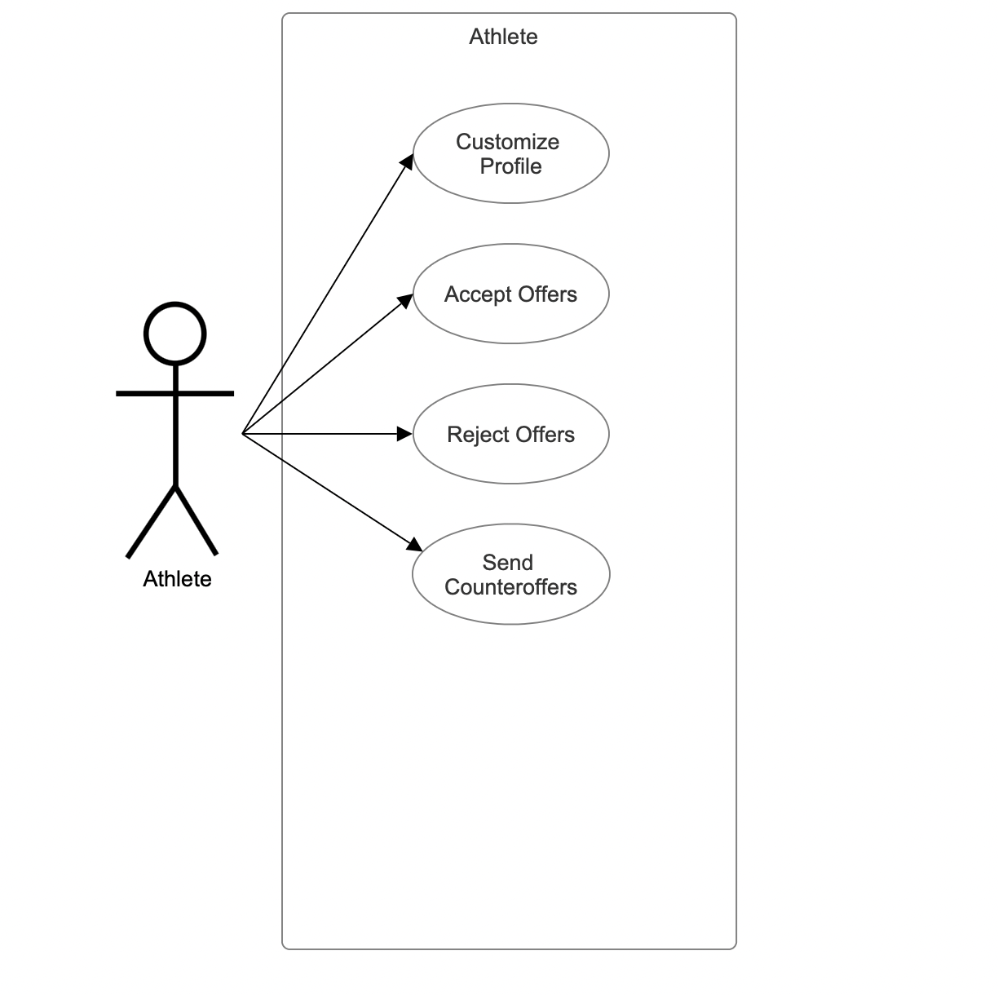

#### **f. Search & Discovery Subsystem:**

* **Description**: Provides a search capability for both companies and athletes.
* **Components**:
* User Search
* Advanced Filtering Options

User Search – Advanced Filtering:

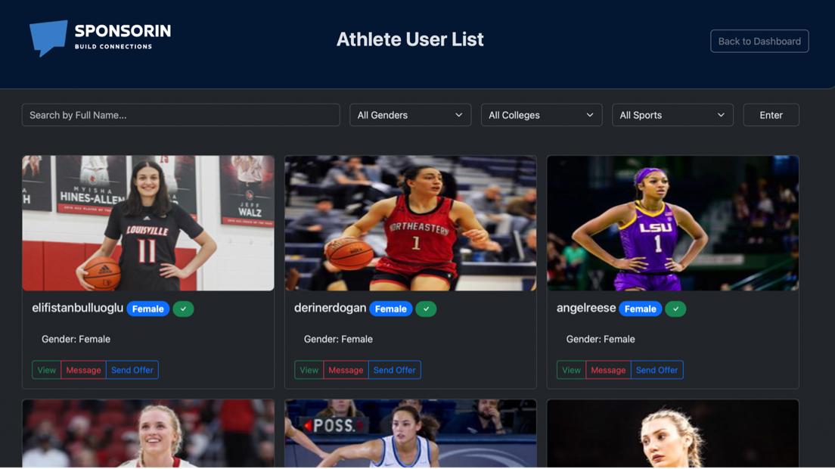

Admins, companies, and athletes are all allowed to search for certain type of users. They also have the ability of using filtering options to match a user with their potential requests and needs.

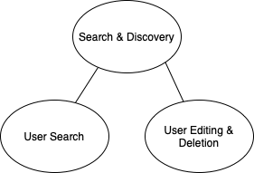

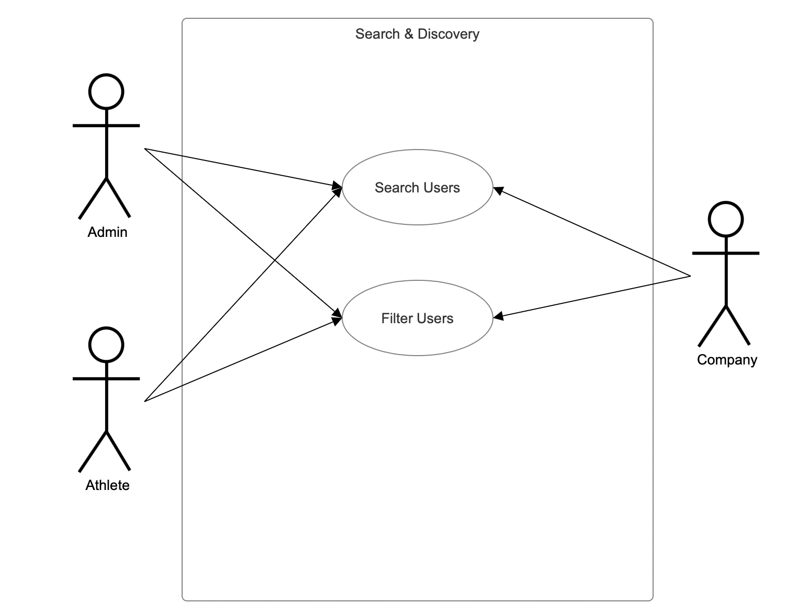

#### **g. UI/UX Subsystem:**

* **Description**: Focuses on delivering an optimal user experience across devices.
* **Components**:
* Responsive - Interactive Design.
* Intuitive Navigation.

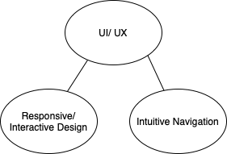

#### **h. Backend Processing Subsystem:**

* **Description**: Deals with the server-side logic, data processing, and other computations.
* **Components**:
* Server Logic (Python Flask).
* Data Processing & Analytics.

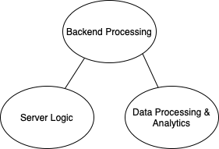

#### **i. Data Management Subsystem:**

* **Description**: Ensures secure, efficient, and reliable data storage and retrieval.
* **Components**:
* Database Engine (PostgreSQL).
* Data Backup & Recovery.
* Data Integrity.

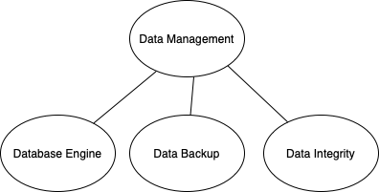

#### **j. Security & Compliance Subsystem:**

* **Description**: Protects user data, ensures secure communication, and enforces platform integrity.
* **Components**:
* Data Encryption (HTTPS, SSL).
* Authorization & Role-based Permissions.
* Secure APIs.

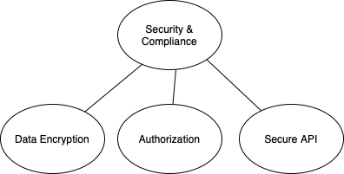

### ***Database Design – Entity Relationship Model and Data Dictionary***

#### **4.2.1 Entity Relationship Model**

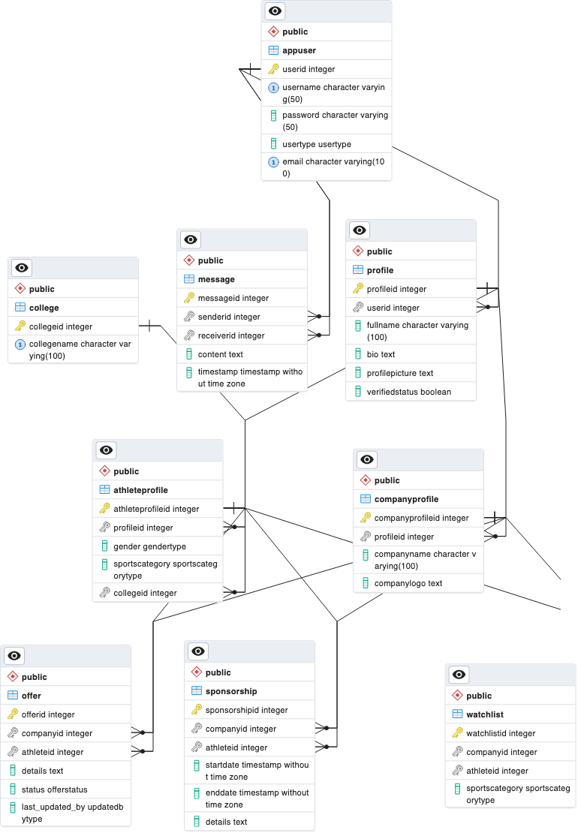

#### **4.2.2. Database Design**

SponsorIN's data architecture is running on PostgreSQL for our database engine. To complement it, we utilize pgAdmin 4, an intuitive GUI that makes database interactions more user-friendly for our team. Our database schema structured into nine distinct tables, each serving a specific function within our platform's ecosystem. We created custom enum types, providing a set of predefined values that reflect the various roles, offer statuses, and sport categories. These types ensure data consistency and enhance the readability of our database logic.

**Enums:**

**UserType**: This enum defines the roles within our community— Admin, Company, and Athlete which helped us creating three distinct dashboards and allowed us to declare which user type can access which functionalities.

**GenderType and SportsCategoryType**: These enums categorize our athletes, ensuring we have a diversity with users and sports.

**OfferStatus**: This enum tracks the progression of negotiations from pending to accepted, declined, and counteroffered, providing clear communication channels and transparency.

**Tables:**

**AppUser**: This table is used when a user is signed up on our platform. It securely holds usernames, passwords, and email addresses, along with each user assigned a distinct role such as if they are an admin, athlete, or company.

**Profile**: Extending from AppUser, the Profile table adds more details about the users such as the usernames, biographical information, and even a profile picture.

**College**: This table stores all the colleges in the United States, so athletes are able to select which college they are currently attending.

**AthleteProfile and CompanyProfile**: These tables branch out from Profile, tailored to the specific needs of our two main user type. AthleteProfile has gender type, sports category, and the college they are attending. CompanyProfile focuses on corporate entities like company name and a field to upload company logo.

**Message**: This table is used to help create our messaging system in our platform as it stores the messages sent between users and creating a unique primary message id for each new message created. senderID references appuser table to see which user sent the message. ReceiverID shows which user is receiving the message. A timestamp field is also added to store the time and date when the message was sent.

**Offer**: This table is used to help create our offer system to capture and manage the sponsorship proposals as it serves a record system of the ongoing engagement between companies and athletes. Each record in the Offer table is uniquely identified by an OfferID, ensuring every transaction is traceable and distinct. The CompanyID column establishes a direct link to the CompanyProfile table, identifying the company user, extending the sponsorship. AthleteID connects to an AthleteProfile and pinpointing the athlete under consideration for sponsorship. Details column provides a field to describe the offer and the amount being offered. Finally, we have a Status column which tracks the progression of the offer through predefined stages which works with our predefined enum type offerStatus. Status column is initially set to 'Pending'. It reflects the current state of negotiations transitioning from pending to acceptance, decline, or even counteroffer.

**Watchlist**: Watchlist table is used to create the functionality for company users as they create their own list of athletes who they consider sponsoring.

**Sponsorship**: This table is used to store and finalize sponsorship deals between the athletes and companies.

#### **4.2.3. Data Dictionary**

|  |  |  |  |  |
| --- | --- | --- | --- | --- |
| Table | Variable | Key | Type | Description |
| appuser |  |  |  |  |
|  | userid | Primary | Integer | ID # of the user |
|  | username | No | Character | Username of the user |
|  | password | No | Character | Password of the user |
|  | usertype | No | usertype | Type of the user |
|  | email | No | Character | Email of the user |
| college |  |  |  |  |
|  | collegeid | Primary | Integer | ID # of the college |
|  | collegename | No | Character | Name of the college |
| message |  |  |  |  |
|  | messageid | Primary | Integer | ID # of the message |
|  | senderid | Foreign | Integer | ID # of the user sent the message |
|  | receiverid | Foreign | Integer | ID # of the user received the message |
|  | content | No | Text | Message itself |
|  | timestamp | No | timestamp | Time message was sent |
| profile |  |  |  |  |
|  | profileid | Primary | Integer | ID # of the profile |
|  | userid | Foreign | Integer | ID # of the user associated with the profile |
|  | fullname | No | Character | Full name of the user |
|  | bio | No | Text | Biography of the user |
|  | profilepicture | No | Text | Profile picture of the user |
|  | verifiedstatus | No | Boolean | Status of the user that shows if the user is verified or not |
| athleteprofile |  |  |  |  |
|  | athleteprofileid | Primary | Integer | ID # of the athlete profile |
|  | profileid | Foreign | Integer | ID # of the profile |
|  | gender | No | gendertype | Gender of the user |
|  | sportscategory | No | sportscategorytype | Sport the athlete plays |
|  | collegeid | Foreign | Integer | ID # of the college athlete attends |
| companyprofile |  |  |  |  |
|  | companyprofileid | Primary | Integer | ID # of the company profile |
|  | profileid | Foreign | Integer | ID # of the profile |
|  | companyname | No | Character | Name of the company |
|  | companylogo | No | Text | Profile Picture of the company |
| offer |  |  |  |  |
|  | offerid | Primary | Integer | ID # of the offer |
|  | companyid | Foreign | Integer | ID # of the company who gave the offer |
|  | athleteid | Foreign | Integer | ID # of the athlete who received the offer |
|  | details | No | Text | Details of the offer |
|  | status | No | offerstatus | Status of the offer |
|  | last_updated_by | No | updatedbytype | User who last updated the offer |
| sponsorship |  |  |  |  |
|  | sponsorshipid | Primary | Integer | ID # of the sponsorship |
|  | companyid | Foreign | Integer | ID # of the company who sponsors athlete |
|  | athleteid | Foreign | Integer | ID # of the athlete who gets sponsored |
|  | startdate | No | timestamp | Start date of the sponsorship |
|  | enddate | No | timestamp | End date of the sponsorship |
|  | details | No | Text | Details of the sponsorship |
| watchlist |  |  |  |  |
|  | watchlistid | Primary | Integer | ID # of the watchlist |
|  | companyid | Foreign | Integer | ID # of the company who created the watchlist |
|  | athleteid | Foreign | Integer | ID # of the athlete who got added to watchlist |
|  | sportscategory | No | sportscategorytype | Type of sport this athlete plays |